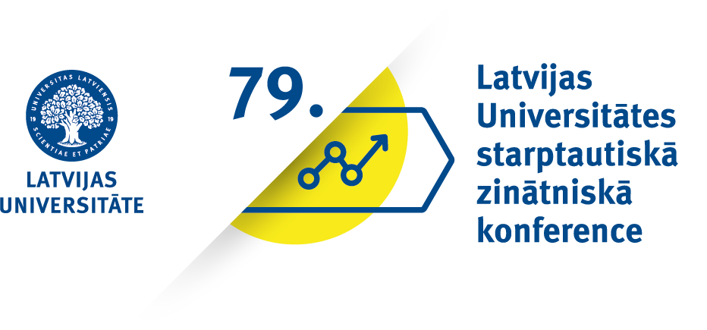 | Impact of Globalization to National Economies and Business  Thursday, 28 January 2021, 3.00 PM Latvian time  Zoom platform https://us02web.zoom.us/j/84605870846
Programma/Programme

Chairs: Prof. Baiba Šavriņa, Prof.Josef Neuert
15.00–15.10 | Prof. BaibaŠavriņa  Latvia  Prof. Josef Neuert  Austria | Opening
15.10–15.25 | Daira Barānova  Latvia | The Impact of the Covid-19 Pandemic on Economic Development in the Eu and Latvia
15.30–15.45 | Matthias Kretschmar  Germany | Application of the Principal-Agent Theory in Commercial Banking Relationships
15.50–16.05 | Markus Huemer  Austria | Impact of Competence Development on Sales Partners Efficiency
16.10–16.25 | Florian Schuessler  Austria | Specialist opinions on digital process maturity and the effects on the efiiciency of product development
16.30–16.45 | Klaus Daenner  Germany | The Impact of Global Digitization on Organization in manufacturing
16.50–17.05 | Markus Filkorn  Germany | Research Outline presentation on doctoral thesis: “The Impact of IT Governance Maturity on IT Performance and Business Success”
17.10–17.25 | Stefan Doubek  Germany | Impact of Leadership effectiveness on the organizational performance of business models in the Automotive Industry
17.30–17.45 | Signe Martišūne  Latvia | Active labour market policies: what works for older workers?
17.50–18.05 | Matthias Paschke  Germany | Influence of employee satisfaction on the commission result of savings banks
18.10 –18.25 | Daniel Schettler  Switzerland | Descriptive comparison of subjective and objective employee performance evaluation
18.30 –18.45 | Sebastian Wunderl  Germany | The influence of Industry 4.0 on production and employees
18.50 –19.05 | Bjarne Erik Roscher  Germany | Development and Validation of Variables for a quantitative survey researching IT Management effectivity and efficiency
19.05–19.... | Conclusions, discussions

